NORTH EASTERN EDUCATION
AND LIBRARY BOARD

EXTENDED SCHOOLS

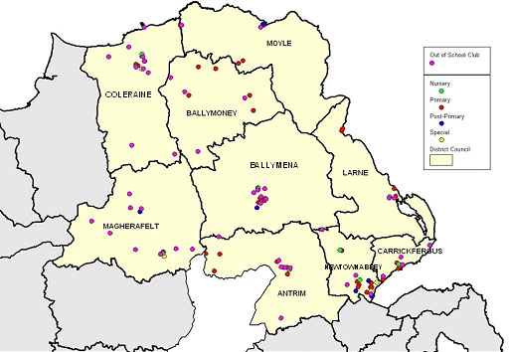

ANNUAL REPORT

2006-2007

CONTENTS

- Introduction and Context
- Overview of the Extended Schools Programme in the NEELB 2006-2007
- Extended Schools Funding
- High Level Outcomes
- Activities/Numbers/Impacts on Pupils, Parents, School and the Community
- Audits
- Engagement with Community, Voluntary and Statutory Agencies
- Benefits/Outcome/Added Value to School
- Challenges of the Extended Schools Programme
- Barriers to Learning and Pupils Ready to Learn
- Innovative Practice
- Conclusion
- Key Learning Points and The Way Forward
- Appendices 1-7
- Acknowledgements

1.0 Introduction and Context

1.1 The Extended Schools concept is at the core of the Children and Young Peoples funding package, providing activities and services which seek to raise school standards, fostering the health, well-being and social inclusion of children and young people and the regeneration and transformation of local communities.

  - The Children and Young Peoples Funding Package is seen as having the potential to make a very
significant contribution to the Government’s 10 year Strategy for Children and Young People in Northern Ireland and within this, Extended Schools have a particular role to play. The Strategy is being built around an Outcomes Framework which provides a basis on which action planning can take place within individual Extended Schools and, if appropriate, across groups of schools. The High Level Outcomes are:

- Being Healthy
- Enjoying, Learning and Achieving
- Living in Safety and Stability
- Economic and Environmental Well Being and
- Contributing Positively to Community and Society

These are based around a central outcome which is ‘Living in a Society which Respects the Rights of Children and Young People.’

  - Selected schools have implemented the Extended Schools Policy in the context of Developing An
Extended School, which is defined as:

- working with Pupils, Families and the Community, as an essential element in raising the standard of pupils’ achievement;
- building partnerships with neighbouring schools, community, voluntary and statutory organisations;
- strengthening families and communities through providing opportunities for lifelong learning and personal development; and
- using its accommodation flexibly and outside of school hours for the good of learners and the community

2.0 Overview of the Extended Schools Programme in the NEELB 2006-2007

  - During 2006/07 the NEELB had a total of 74 Extended Schools. Table A below shows Extended Schools as a % of the total number of schools by sector in the NEELB area.

Table A
Participating Extended Schools | % Extended School
33 Controlled Primary Schools | 26%
15 Maintained Primary Schools plus 1 Good Practice School | 21%
1 Grant Maintained Integrated Primary Schools | 17%
3 Controlled Integrated Primary Schools | 60%
7 Controlled Nursery Schools | 27%
2 Maintained Nursery Schools | 12%
6 Special Schools | 55%
5 Controlled Post Primary Schools | 21%
1 Maintained Post Primary School | 7%

2.2 The information provided in this NEELB Annual Report is taken from Extended Schools’ Annual Reports (62/74 return rate), information and analysis of Action Plans and training provided during the first year of practice by Extended Schools.

2.3 Further to the completion of the first year of the Extended Schools Initiative findings suggest that the initiative can have positive effects on the participating children, schools, families and communities.

2.4 The majority of the 74 participating schools have reported associated benefits in attendance, behaviour, self-esteem, and confidence; many have provided accredited courses for both children and adults which have given a great sense of achievement; and all activities and services provided have strengthened links with the community.

2.5 Schools reported a very short lead in period prior to the implementation of Extended Schools, but have since embraced the concept and as one Extended School reports, now see it as, ‘an Integral part of School Life and School Development Planning.’

3.0 Extended Schools Funding

3.1 As part of the Children and Young Peoples Funding Package the NEELB was awarded
£ 1,435,457 in respect of Extended School Funding.

  - Table B below shows the 2006/07 funding allocation per school, including an additional 15%
allocation for 50/74 schools who operated in a cluster during 2006/07.

Table B
School | 06/07 Individual ES Allocation £ | Cluster Funding £
Controlled
Abbots Cross PS | 25,525 | 3,829
Armoy PS | 8,900 | 1,335
Ballee HS | 27,375 | 4,106
Ballee PS | 11,400 | 1,710
Ballycastle HS | 26,600 | 3,990
Ballyclare NS | 10,800 | 1,620
Ballyclare PS | 30,930 | 4,640
Ballycraigy PS | 13,825 | 2,074
Ballykeel PS | 25,950 | 3,893
Ballymena NS | 8,000
Ballysally NS | 8,200 | 1,230
Ballysally PS | 21,600 | 3,240
Bushmills PS | 14,350 | 2,153
Bushvalley PS | 17,050 | 2,558
Camphill PS | 26,125 | 3,919
Carnlough PS | 7,100
Carnmoney PS | 26,525
Carrick Central PS | 20,125
Carrick Model PS | 28,200
Dunclug NS | 8,200
Dunclug PS | 14,950 | 2,242
Duneane PS | 6,100
Earlivew PS | 16,675
Harpurs Hill PS | 20,200 | 3,030
Harryville PS | 15,025 | 2,254
Hollybank PS | 20,425
Killowen PS | 19,600 | 2,940
King’s Park PS | 26,925 | 4,039
Kylemore NS | 8,200 | 1,230
Leaney PS | 25,700
Maghera HS | 18,475
Magherafelt NS | 10,800 | 1,620
Magherafelt PS | 26,500 | 3,975
Millburn PS | 28,500 | 4,275
Monkstown HS | 32,730 | 4,910
Mossley NS | 8,200
Mossley PS | 31,670
Moyle PS | 25,250 | 3,788
Newtownabbey HS | 27,850 | 4,178
Parkhall PS | 23,700 | 3,555
Rathcoole PS | 21,350 | 3,203
Silverstream PS | 16,225
Sunnylands PS | 19,525
Whitehouse PS | 26,725 | 4,009
William Pinkerton PS | 9,500
Controlled Integrated
Ballycastle IPS | 10,200 | 1,530
Rathenraw PS | 12,800 | 1,920
Round Tower PS | 17,125 | 2,569
Grant Maintained
Carlane PS | 8,200 | 1,230
Edmund Rice | 31,350 | 4,703
Holy Family PS | 30,390 | 4,559
St Anne’s PS,Corkey | 10,600 | 1,590
St Anthony’s NS | 8,200 | 1,230
St Anthony’s PS | 14,800 | 2,220
St James PS | 22,800 | 3,420
St John’s PS, C’raine | 20,200 | 3,030
St John’s PS,C’lough | 19,675
St Joseph’s NS | 8,200 | 1,230
St Joseph’s PS, Antrim | 23,500 | 3,525
St Joseph’s PS, B’mena | 10,700 | 1,605
St Joseph’s PS, Crumlin | 16,840
St Mary’s on the Hill PS | 25,500
St Nicholas PS | 13,525
St Oclan’s PS | 9,200 | 1,380
St Oliver Plunkett’s PS | 16,525 | 2,479
St Patrick’s PS, L’guile | 19,975 | 2,996
Tir-na-Nog PS | 6,100 | 915
Special Schools
Dunfane SS | 16,675 | 2,501
Hillcroft SS | 11,100
Jordanstown SS | 10,300
Kilronan SS | 10,500
Roddensvale SS | 10,800 | 1,620
Sandelford SS | 16,300
Total | 1,299,660 | 135,797
Grant Maintained IPS paid by DE
Corran IPS | 18,475 | 2,771
Overall Totals | 1,318,135 | 138,568

3.3 In total, during 2006/07 schools have spent £ 564,717 which represents 39% of the overall Extended Schools’ allocation. The first year of expenditure for Extended Schools was in the main confined to January 2007 - March 2007. During 2007/08 an increase in % spend is expected, as there will be a full financial year in which to register expenditure.

3.4 Extended Schools have already profiled the 2006/07 carryover as part of Extended Schools Action Plans matched with 2007/08 budgets. The NEELB is working closely with schools in order to increase activities and services provision that will reduce any potential underspend in 2007/08.

4.0 High Level Outcomes

4.1 The objectives of the Extended Schools Initiative are to achieve positive impacts based on the 5 High Level Outcomes. Extended Schools have identified needs and constructed additional and complementary programmes, forming an Extended Schools Action Plan, to meet one or more of the High Level Outcomes.

  - The following Tables C & D show the number and type of activities which took place during
2006/07 compared with the proposed actions for 2007/08. Tables C and D show how an individual activity contributes to ONE HLO.

Table C
Impacts on High Level Outcomes – 06/07
High Level Outcome/Activity | Being Healthy | Enjoying, Learning & Achieving | Living in Safety & with Stability | Experiencing Economic & Environmental Well-being | Contributing Positively to Community & Society
Breakfast Club | 30
Afterschool Club |  | 20
Healthy Eating | 16
First Aid |  |  | 4
Health & Fitness | 17
Literacy/Numeracy/ICT |  | 24
Summer Scheme |  |  |  | 5
Language Club |  | 10
Sport | 39
Science Club |  | 8
Homework Club |  | 14
Youth Activities |  |  |  | 4
Drama/Dance |  | 22
Hillwalking | 3
Music |  | 21
Art/Craft/Design |  | 15
Cookery |  | 6
Story/Toy Library |  | 3
Parenting/Family |  |  |  |  | 32
Community Links |  |  |  |  | 5
Recycling/Eco Activities |  |  |  | 10
Totals | 105 | 143 | 4 | 19 | 37 | 308
Table D

Proposed Impacts on High Level Outcomes – 07/08
High Level Outcome/Activity | Being Healthy | Enjoying, Learning & Achieving | Living in Safety & with Stability | Experiencing Economic & Environmental Well-being | Contributing Positively to Community & Society
Breakfast Club | 27
Afterschool Club |  | 19
Healthy Eating | 20
First Aid |  |  | 7
Health & Fitness | 29
ICT & Key Skills |  | 25
Summer Scheme |  | 8
Language Club |  | 17
Sport & Sporting Skills | 38
Science Club |  | 6
Homework Club |  | 16
Youth Activities & Skills |  | 23
Drama/Dance |  | 26
Specialist Clubs/Skills |  | 15
Music |  | 16
Art/Craft/Design |  | 15
Cookery | 3
Extended School Co-ord
Parenting/Family |  |  |  |  | 35
Community Links |  |  |  |  | 6
Recycling/Eco Activities |  |  |  | 14
Totals | 117 | 186 | 7 | 14 | 41 | 365

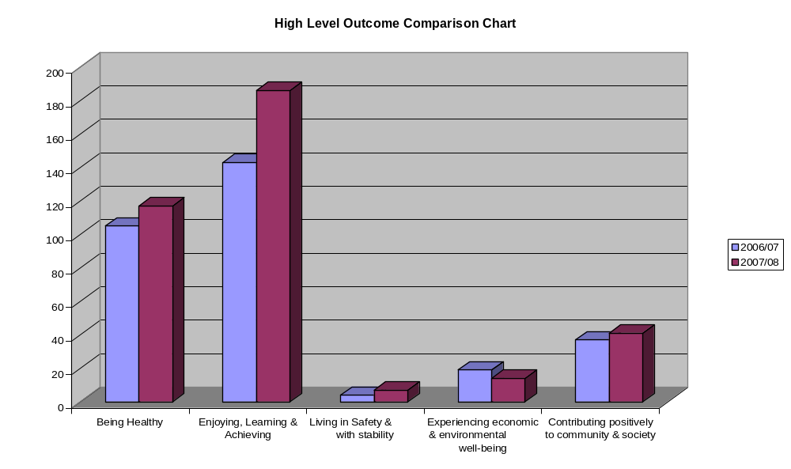

4.3 Table E below shows how an activity may contribute to one or more HLO in 2007/08, e.g. a
sports activity may in fact contribute to Enjoying, Learning and Achieving as well as Being Healthy.

Table E
High Level Outcomes – 07/08
School/Activities | Being Healthy | Enjoying, Learning & Achieving | Living in Safety & with Stability | Experiencing Economic & Environmental Well-being | Contributing Positively to Community & Society
Total | 204 | 324 | 44 | 35 | 154

  - The graph shows that Being Healthy and Enjoying, Learning and Achieving are the predominant
HLOs. In discussions with schools, we can record that this is as a result of:

- Schools being driven by targets of raising standards and achievements and therefore it has been easier to impact on Enjoying, Learning and Achieving
- Many schools have been involved before in after schools projects and healthy initiatives
- Living in Safety and Stability and Economic and Environmental Well-Being are relatively new to many schools and these require more exploration in the development of their Extended Schools activities and services.
- The NEELB Extended Schools team have worked with schools in the development of 07/08 action plans and as a result the number of activities/services which Contribute Positively to Community and Society has increased.

5.0 Activities/Numbers/Impacts on Pupils, Parents, School and the Community

5.1 Individual Action Plans

74 Extended Schools participated in the Initiative during 2006/07, including one Good Practice School which provided opportunities for dissemination. According to Table C a total of 308 activities and services took place in 2006/07 attended by 7808 participants. The proposed number of activities for 2007/08 is 365 (Table D), an increase of 19%.

  - Table F and the graph on the next page show a breakdown of activities/services by number of
pupils/parents, e.g. 843 pupils attended breakfast clubs and a total of 415 parents/adults engaged in extended activities and services during 2006/07. Appendix 7 shows activities and services mapped according to council areas.

 | Breakfast Club | After School Club | Healthy Eating | First Aid | Health & Fitness | Lit/Num/ICT | Summer Scheme | Language Club | Sport/Sporting | Science Club | Homework Club | Youth Activities | Drama/Dance | Hillwalking | Music Club | Art/Craft/Design | Cookery | Story/Toy Library | Parenting/Family | Community Links | Recycling/Eco Activities | Totals
Pupils | 843 | 598 | 555 |  | 595 | 317 | 91 | 139 | 1426 | 284 | 253 | 80 | 591 | 94 | 278 | 389 | 14 | 35 | 388 | 383 | 40 | 7393
Parents |  |  |  | 72 | 28 | 120 |  |  |  |  |  |  | 74 |  |  | 68 | 9 | 1 | 35 |  | 8 | 415
Totals | 843 | 598 | 555 | 72 | 623 | 437 | 91 | 139 | 1426 | 284 | 253 | 80 | 665 | 94 | 278 | 457 | 23 | 36 | 423 | 383 | 48 | 7808
Table F Individual Activity Table 06/07
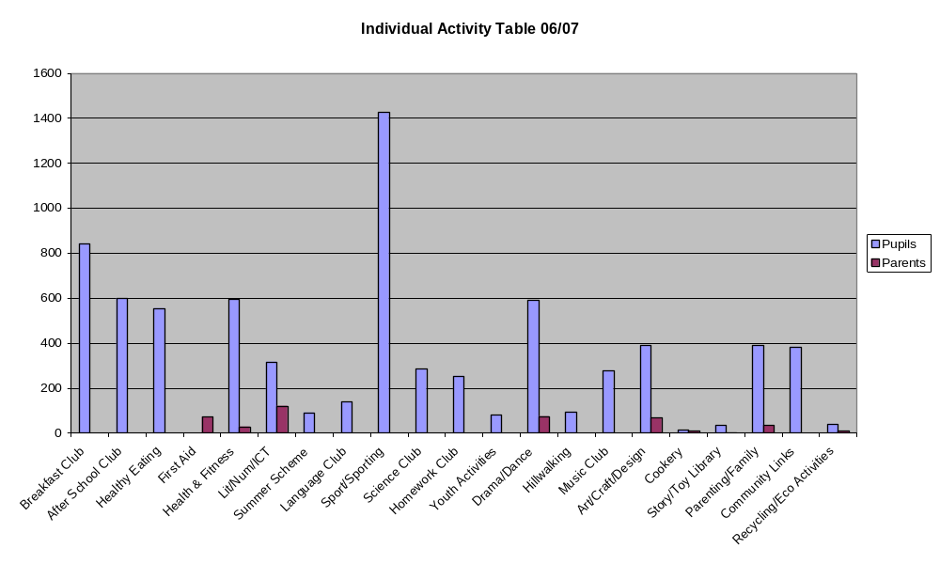
See Appendix 7 ‘Mapped Activities’

  - All participating pupils, parents and the wider community have provided positive feedback, reporting that the activities they were involved in have been beneficial, rewarding and have provided a sense of achievement. Examples of comments/details from school reports include:
- Breakfast clubs have provided a means for increasing punctuality, thus reducing the number of late comers, increasing concentration levels and encouraging healthy eating habits.
- Parents report that they are able to increase their working hours, reduce the number of pick-ups at school, return to education themselves, help their children with homework as they themselves have upskilled and help them to feel part of a whole school community.
- Afterschool/break and lunchtime clubs have reduced incidences of misbehaviour, channelled aggressive behaviours, enhanced skills through professional coaching including team building, sharing and problem solving, increased cultural awareness and understanding, given accreditation, raised self esteem and confidence levels.

Parent: ‘My daughter is now able to show her young brother and sister what she has learnt.’

Teacher: ‘Before having the homework club a third of homework would not be completed or would not be completed to an acceptable standard. A quiet area and resources (staff) in school has helped increase the homework return rate and enhance the quality of homework.’

Pupil: ‘I loved coming to school on a Monday because I was allowed to play Gaelic.’

5.4 It is also important to note that not all planned activities took place and this was as a result of lack of numbers or availability of coaches/tutors. This will be an ongoing issue for schools as they seek to review and be responsive to identified needs. Also the introduction of the Extended Schools Initiative immediately increased demand for coaches, thus supply was reduced. Many schools are working together as part of their cluster to share coaches/tutors.

(See Appendix 1 for a synopsis of the Annual Report ‘Impacts Activities/Services’)

  - Cluster Action Plans

The Extended Schools policy encourages Extended Schools to work in partnership, both with each other and with outside agencies. This was reinforced through provision of an additional 15% funding (see Table B) for 3 or more funded Extended Schools that participated in a cluster activity. During 2006/07 a total of 50/74 Extended Schools were part of 11 clusters (see Table G below) collaborating on a number of themes to produce activities/services which included:
  - Multi-Sports
  - Cultural/Drama (Around the World)
  - Healthy Eating
  - Summer Scheme
  - Afterschools Club
  - Cross Community Irish Dancing
  - Adult Classes (computers, over 55s)
  - Family Activities

The schools have reported benefits of clusters as giving them an opportunity to:

- Bring in external professionals to deliver a specific piece of work; and
- Share and maximise the use of space and build links with the community
Table G
Extended Schools Clusters 06/07

Moyle | Antrim | Ballyclare | Magherafelt
Ballycastle HS  Ballycastle IPS  Bushvalley PS  Bushmills PS  St Patrick’s PS, L’guile  St Anne’s PS  St Olcan’s PS  Armoy PS | St Joseph’s PS  St Joseph’s NS  Rathenraw IPS  Round Tower IPS  Parkhall PS  Ballycraigy PS | Tir-Na-Nog PS  Ballyclare PS  Ballyclare NS | Carlane PS  Magherafelt PS  St Oliver Plunkett’s PS  Holy family PS  Magherafelt NS
Coleraine | Churchlands | Larne | Ballymena 1
Ballysally PS  Millburn PS  Harpur’s Hill PS  Ballysally NS | Killowen Ps  St John’s Ps, Coleraine  Kylemore NS | Moyle PS  Roddensvale SS  St Anthony’s PS  St Anthony’s NS  Corran IPS | Camphill PS  Ballee HS  Ballee PS  Ballykeel PS  Harryville PS
Ballymena 2 | Newtownabbey 1 | Newtownabbey 2
Dunclug PS  St Joseph’s PS  Dunfane SS | Monkstown CHS  Edmund Rice College  St James PS  King’s Park PS | Newtownabbey CHS  Abbotts Cross PS  Rathcoole PS  Whitehouse PS

  - Audits

  - The timing of the Extended Schools Initiative made it more difficult for schools to carry out detailed
audits, yet schools did carry out surveys within the school and through questionnaires to parents (parent response rate was poor) and the community. As the Extended Schools Initiative has developed schools have increased their amount of research, consulting with many external providers, including local community, voluntary and statutory organisations as they seek to dovetail and complement existing provision in their local area.

  - In the ETI Baseline survey it was reported that there were wide variations in schools’ approaches to auditing. ‘In the best practice, a small number of schools were engaged in consultations with stakeholders, including neighbouring schools and the community…’

Examples of school consultations included:

- Questionnaires with pupils and parents, PTA and Pupil Councils
- Consultation with the community through the newsletter
- Information evenings for parents and community
- Local community forum and DSD Neighbourhood Renewal meeting
- Audit completed in conjunction with School Development Plan to identify gaps.

(See Appendix 2 for a synopsis of the Annual Report ‘Audit’ Responses)

6.3 Schools recognise the importance of meeting needs but also acknowledge the difficulty there is in making sure there is no duplication. The NEELB Extended Schools team produced a ‘Baselining and Action Planning,’ document which schools used as a means of identifying needs. There was also the difficulty finding out about activities and services already taking place in the local community. Schools contacted various community associations, funding bodies and the voluntary and statutory sectors to determine levels of existing programmes and potential for duplication. In some ways this has contributed to partnership working.

  - Schools recorded that the Extended Schools Exhibition held in Antrim Board Centre helped them to
establish needs and was a useful means of making contact with the various agencies to find out what they could provide and what they were doing already. This event was attended by 28 community, voluntary and statutory agencies and 54/74 Extended Schools.

When asked about Auditing in the Annual Reports:

- One school asked the question to parents: What can you bring to your school? As a result, one parent ran a baby massage course attended by the cluster schools.
- Another school offered a night with no homework to pupils completing the survey!

7.0 Engagement with Community, Voluntary and Statutory Agencies

7.1 Schools have embraced the concept of working in partnership and collaboration, consistent with the ethos of the Extended Schools Policy and the findings of the ETI Baseline Survey. This is evident in the programmes facilitated by schools and the consultation that has taken place.

7.2 The ETI Baseline Survey reports that a significant minority of schools already have established relationships with other local schools, community and other organisations. However, in general, the level of partnership and collaboration with outside agencies and organisations is modest. This is an area for further development in 2007/08.

  - During 2006/07 Extended Schools engaged with 68 external providers, i.e. those coming into schools
to carry out a piece of work with the pupils, parents and/or the community. Whilst some schools have had issues of availability, all schools who engaged in partnership working have heaped praise on their external partners for their professionalism, resources and high standard of service provided. Schools have reported,

‘It has brought a new dimension to school having sports coached by professionals and it also means that teachers do not have to do it all themselves.

‘We were able to use the local community centre as we had no available space in school.’

  - The NEELB Extended Schools team would like to acknowledge the support of the NEELB Project
Board which includes Barnardos, Council for Catholic Maintained Schools, Northern Health and Social Services Board, Department for Social Development and NEELB Finance, Early Years and Schools Branch departments. The support of the Project Board has been crucial in the development of the Extended Schools Initiative through facilitation of more than 10 meetings during the first year (Sept 07 – March 08), knowledge of local needs and local activities and services, which has assisted in making informed action plan recommendations.

(See Appendix 3 for a synopsis of the Annual Report ‘Partnership’ Responses)

8.0 Benefits/Outcomes/Added value to School

8.1 All Extended Schools experiences have been positive, providing opportunities for increased
participation, improved levels of engagement with parents and the wider community, and raised educational standards and achievements with the potential to take this to another level.

Schools reported:
- Activities allowed for the re engagement of the disaffected pupils
- There is a buzz in and around school
- As a result of the arts and crafts two parents have set up small businesses
- Relations have improved between pupils, parents and the community
- The cluster project has been instrumental in breaking down barriers between us (Special School) and mainstream
- The amount of traffic at schools has reduced at peak times
- We now have the opportunity to work with children at home prior to coming to schools
- The school has had successes in dance and sporting competitions
- Parents have received accreditation, help children with their homework and are keen to participate in further study

(See Appendix 4 for a synopsis of the Annual Report ‘Outcomes/Added Value’ Responses)

9.0 Challenges of the Extended Schools Programme

9.1 The main challenges for schools have included:

- The timing of the introduction of Extended Schools
- Putting in place the appropriate systems for administration, monitoring and evaluation
- Selling the Extended Schools Initiative to the Whole School Community
- Lack of space in the school
- Picking up children in the afternoons proved difficult for special and nursery schools, as did not being able to operate non curricular activities during the school day
- Having access to coaches and tutors
- Ensuring appropriate audit and no duplication of services

  - Turning challenges into opportunities schools reported,

‘One disaffected pupil enjoyed an activity so much that she was asked to assist the tutor in teaching others. This responsibility has had positive effects on their re engagement within school.’

‘Having the Extended Schools programme far outweighs the challenges of administration.’

  - Principals were proactive in engaging with the school community and in particular selling the idea to
the Board of Governors and Staff. This was achieved and through Board of Governor training facilitated by the NEELB Extended Schools Team, Governors evaluations showed the Extended Schools Initiative and the training to be worthwhile:

Table H
Number of training sessions | Number of Governors Attending |  | Overall Course Evaluation
 | Total No | Average per session | V Effective | Effective
2 | 25 | 12 | 83% | 17%

9.4 When the schools and the principals realised that they didn’t have to do everything themselves, the Extended Schools concept developed and made good progress during year one. The progress was evident in the schools who appointed an Extended Schools Co-ordinator, and indeed, in one cluster of schools a non-teacher was appointed and has managed the Extended Schools cluster programme and supported the individual schools comprising the cluster with positive results.

9.5 Many schools have appointed external coaches/tutors and agencies to deliver projects, monitor and evaluate outputs and outcomes. Whilst this gives outside bodies greater autonomy it allows for shared responsibility in regards measuring effectiveness of projects and it has further assisted schools to carry out their primary function of teaching the curriculum which the Extended Schools programme can complement.

9.6 Some schools have limited space and have worked in partnership with local community associations and councils to provide space for activities, giving added benefits to all parties.

  - Training and Information sessions have been provided by the NEELB Extended Schools Team and
the Regional Training Unit to support the setting up of new administrative systems and NEELB Internal Audit has given schools a Financial Monitoring Tool in order to track expenditure. All support materials be accessed via the NEELB website, www.neelb.org.uk/schools. Provision of training and information sessions for principals and co ordinators will continue during 2007/08.

(See Appendix 5 for a synopsis of the Extended Schools ‘challenges.’)

- Barriers to Learning and Pupils Ready to Learn

10.1 For many schools extended activities and services did not start until October/November 2006 or
indeed January 2007 for others. This has effectively turned the first year of Extended Schools into a 3 month programme, January 2007 – March 2007. This has reduced the opportunities for impacts and it will therefore be in subsequent years when the outputs and outcomes can be measured more effectively in relation to raising standards and achievements of the children and young people. In posing the question, the table below shows the results of ‘to what extent did the Extended Schools programme remove the barriers to learning or make pupils more ready to learn?’ The latter part of the question, ‘making pupils more ready to learn,’ was certainly met as an outcome, and analysis of the qualitative evaluations provides evidence that as a result of the Extended Schools programme a positive difference has been made to the lives of participating pupils, parents, families and communities. It is anticipated that in future years this will be further developed and built upon with even greater impacts on inclusion, participation and ultimately learning, achievement and raising standards.
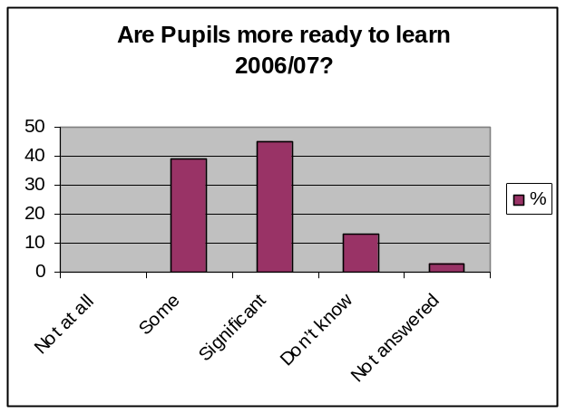
Table I
Are pupils more ready to learn? (06/07)
 | Schools | %
Not at all | 0 | 0
Some | 24 | 39
Significant | 28 | 45
Don’t know | 8 | 13
Not answered | 2 | 3
Totals | 62 | 100

- Innovative Practice

The schools have been very modest in identifying good or innovative practice, as shown by the 74/74 completed Monitoring Visits, yet many have put in place administrative systems and programmes of activity and services which can and have been replicated in other schools and communities. Some of these innovative practices are outlined below:

- Setting up administrative and financial systems to track expenditure. One school secretary has visited other schools in the cluster to help them set up the similar systems.
- Setting up a healthy fruit tuckshop managed by pupils, with funds used for sustainability of the project.
- Provision of first aid in a rural community where emergency services are more than 20 miles away. This has led to development of a defibulator training course during 2007/08.
- Use of the non-teaching cluster co ordinator to support the smaller cluster schools, most of whom are teaching principals.
- A science project has won an award for the teacher, ‘Science Teacher of the Year,’ and attracted a grant award, thus assisting with sustainability and development of the science project.
- Opening the school during the summer months, something which has never happened before.

(See Appendix 6 for a synopsis of the Annual Report ‘Innovative Practice’ summaries)

- Conclusion

12.1 Findings from the first year evaluations suggest that the Extended Schools Initiative can make a difference, and therefore schools should persevere with the implementation and development of extended provision. During a period of change for schools with the Revised Curriculum and renewed emphasis on School Development Planning, Extended Schools has a strategic and important role in the future of schooling and learning.

12.2 As the ETI Baseline Survey reported, ‘it will take time and confidence for schools to get used to thinking and working in a more creative and collaborative way. Given that school improvement is at the heart of the Extended Schools Initiative, a significant minority of schools need to articulate more specifically how their extended provision will lead to improvements in the children’s learning and achievement.’

12.3 The NEELB Extended Schools team looks forward to 2007/08 to see programmes develop and become more established with greater involvement, responsibility and ownership from all community, voluntary and statutory stakeholders.

- Key Learning Points and The Way Forward

13.1 The Extended Schools Initiative has been shown to contribute to the re-engagement of individuals and families in aspects of school life. For the pupils this has brought educational benefits that will lead to improvements in learning, achievement and ultimately standards.

  - Schools have embraced the concept and embarked on an Extended Schools journey with enthusiasm
and energy with the focus on bringing added benefits to the whole community, of which the school plays an integral role. Schools have already engaged in further consultations and audits in relation to 2007/08 and similar commitments and enthusiasm have been shown from the community, voluntary and statutory sectors. All stakeholders hope that the Extended Schools Programme extends well beyond the current funding period, consistent with the 10 year Children & Young Peoples Strategy. Both the schools and the agencies have witnessed the added benefits these complementary support programmes have brought to the pupils, parents and wider community.

  - As part of the future development of schools, the Extended Schools Policy and actions need to
become firmly embedded into the culture and the fabric of schools and should form an important part of School Development Planning. This will provide for greater certainty for the future of the Extended School and place its importance in context, that it is seen as part of a joint solution, working towards ‘reducing underachievement and improving life chances of children and young people.’

14.0 Appendices 1-7

APPENDIX 1

IMPACTS OF ACTIVITIES/SERVICES (for Pupils, Parents and the Community)AS NOTED IN SCHOOLS’ ANNUAL REPORTS

Pupils
- Healthy start to the day, increased concentration and stamina in class.
- Children having fun, enjoying exercise and developing new skills.
- Good to have the class in school building instead of having transport difficulties.
- Few computer access to internet at home, coupled with a breakfast which many children come to school without.
- Before homework club, 1/3 of children’s homework would not have been completed or not been of an acceptable standard, quiet area and available resources has helped.
- Informed children are making healthy choices.
- Increased awareness of the importance of exercise in order to maintain a healthy lifestyle. One parent said that their daughter was able to show their younger brothers and sisters what they had learnt!
- Helped us to get on with our parents as we were teaching them. Reassured parents
- Children more aware of cultural diversity through cluster activity. The final drama production involving the cluster schools enhanced community spirit, confidence and self esteem.
- Improvement in study habits of children.
- Youth Club made a valuable contribution to develop social and life skills of participants.
- Complete absence of misbehaviour in the before school period.
- More confident pupils, proud of their work, linked to new transforming status.
- Improved listening skills in P1 children.
- Working as a team in an environmentally friendly way.
- Great sense of pride, new skills in items made by pupils and parents.
- Training for staff to ensure sustainability, e.g. counselling, health and hygiene, positive behaviour.
- Lovely to see motivation, enthusiasm, involvement of the children, especially those with special needs.
- Staff were able to follow up progress made in ES activities.
- Opportunities for some children to show a unique flair.
- Dance allowed for creativity and imagination to be explored.
- Better prepared transition from Nursery to Primary to Post Primary School.
- Parents commented that children want more water at home.
- More confident in speaking out (Speech & Drama).
- Cross community relations improved through cluster, respect, tolerance.
- The parenting classes acted as a forum for parents to discuss issues of mutual concern (autism information sessions).
- Judo has been a way to address pupil’s aggression.
- Team spirit, skills.
- Increased awareness of internet safety.
- Interactive programmes to help children’s learning.
- Role models for peers.
- Two persistent late comers now on time for school.
- More alert at start of day.
- Improved results GCSE maths.
- Wrote and produced high quality music CDs.
- Students (Primary School) worked with the UU and the Institute of Civil Engineers on a science project and won science teacher of year a top award from Rolls Royce, culminating in a £5000 grant for the school.
- Developing healthier attitudes to their bodies.
- Team work skills and social interaction developing really well. It’s the first time P1-P5 have had the experience of after schools activities.
- Pupils were pleased when their parents received certificates.

Parents

- Convenient for parents for work and one pick-up at school.
- To know more about computers and the Internet. Increased confidence, formed new friendships.
- Improved communications between school and parents.
- Improved parent and pupil self esteem and skills.
- Opportunities for capacity building with parents.
- Parents and grandparents attended the ICT course, one pensioner went on to have broadband fitted at home.
- Allowed parents to extend part time working hours.
- Two people have embarked on small businesses as a result of the art & craft class.
- Some adults have volunteered to help facilitate the ICT class next year.
- Salsa dancing enabled relationships to be fostered between community and school.
- Parents gained a level 2 qualification in computers, can now help their children.
- Delighted with ones stop shop approach.
- Helped adults to overcome fear of computers.
- Parents were able to gain skills in first aid in a rural area which has restricted access for the emergency services.
- Parents were able to gain skills in first aid in a rural area which has restricted access for the emergency services.
- Parents love the flexibility of the service.

Community

- Youth Club reduced number of complaints about children from residents.
- Children directly involved in helping elderly people in the community.
- Less waste paper in the playground.
- Better use of school during the summer months.
- Parents were able to gain skills in first aid in a rural area which has restricted access for the emergency services.

APPENDIX 2

AUDIT: AS NOTED IN SCHOOLS’ ANNUAL REPORTS

Types of Audit carried out

- Baseline survey.
- Questionnaires pupil/parent.
- Consulted with community through newsletter.
- Personal discussions with pupils/parents.
- Focus groups.
- Met with agencies at ES Conference.
- Consulted ‘whole school community’.
- SETAQ questionnaire to parents.
- PTA, School Council.
- Feedback during latter courses, photographs.
- Dedicated time for families to call into school and sign up.
- Asked parents what they could bring to the school – results are parents running baby massage class.
- Pupils let off homework if survey completed.
- Information evening for parents.
- Children and young peoples forum and at DSD NR meeting.
- Audit completed in conjunction with school Development Plan, identifying gaps.
- Have ensured audit goes beyond the school community for 07/08.

Comments relating to the Audit Process

- Poor response to questionnaires by parents.
- Questionnaire response was not always an indication of commitment, shown through attendance.

APPENDIX 3

BENEFITS OF PARTNERSHIPS: AS NOTED IN SCHOOLS’ ANNUAL REPORTS

- Provided materials and personnel.
- External agencies provided promotional posters on the importance of a healthy breakfast.
- NEELB Youth Service very useful.
- Met with external agencies to ensure no duplication.
- Use of the community centre has ensured additionality
- Developed positive relationships.
- Parental expertise drawn upon.

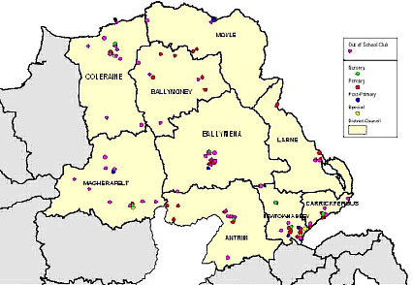

APPENDIX 4

OUTCOMES/ADDED VALUE (for Pupils, Parents and the Community) AS NOTED IN SCHOOLS’ ANNUAL REPORTS

Pupils
- Fun, exercise and learning new skills in a safe and friendly environment.
- Playing with equipment that is not available during the normal school day.
- Increased options for children, who are now healthier and gave them opportunities to build friendships with children from other year groups.
- Having had a good breakfast increased concentration levels in class.
- Activities also allowed for re-engaging of disaffected pupils.
- Pupil’s motivation and self esteem have increased.
- Improved pupil behavioural attitude to school, improved relationships with parents and local community.
- There is a buzz within the school.
- Keep children off the street.
- Working in a network of principals to overcome challenges.
- Instrumental in breaking down barriers between our pupils and mainstreams. They could now join dance groups in their local area.
- More efficient use of therapist’s time, reduction in waiting lists.
- Created the opportunity to work with children in the home, introduce them to school before they actually come to school.
- He has brought me home some lovely pictures and cards, and his handwriting has greatly improved.
- Helps those children who may shine on a sports field as opposed to academically.
- As staff come on board implementation of ES became easier.
- “I loved a Monday because I got to play Gaelic”. Increased pupil’s enthusiasm for school.
- Teachers from numerous schools across NI have visited the school to view best practice.
- Improved attitudes to science when pupils come into school.
- Success in competitions (sports, dance).
- Improvements in literacy and numeracy scores.
- More settled and ready for class after breakfast club.
Parents
- Social interaction for parents, pupils and teachers.
- All parents and children received certificates.
- Enabled a breaking down of barriers to learning for parents.
- There is a buzz within the school.
- Flexible childcare.
- Parents felt ‘they were not alone’.
- More efficient use of therapist’s time, reduction in waiting lists.
- Created the opportunity to work with children in the home, introduce them to school before they actually come to school.
- He has brought me home some lovely pictures and cards, and his handwriting has greatly improved.
- Parents now see school as a community resource.
- ICT skills helped parents in their own work and some want to go on to further study.
- Parents felt pressure taken off at home.
- Some parents have returned to education as a result of after schools clubs.

Community

- Made links with the local after schools club and intend to develop this next year.
- There is a buzz within the school.
- Keep children off the street.
- Working in a network of principals to overcome challenges.
- Reduction in amount of traffic at normal pick up times.
- More efficient use of therapist’s time, reduction in waiting lists.
- Parents keeping watchful eye on school play facilities being used in the evenings.
- Parents now see school as a community resource.
- As staff come on board implementation of ES became easier.
- Teachers from numerous schools across NI have visited the school to view best practice.
- Our schools becoming the hub of the community.

APPENDIX 5

CHALLENGES AS NOTED IN SCHOOLS’ ANNUAL REPORTS

Administrative

- Admin, hours, payments. Appointment of co-ordinator has helped.
- Admin and paper work great burden but the outcome of having the ES programme far out weighs the challenges of admin.

Practical

- Time to do a good job.
- Teaching principal getting the time to make calls, organise coaches etc.
- Time to consult was overcome through sub cover time given which was invaluable.
- No space in our school hall, so used local Youth Centre.
- Transport as a special school proved difficult but targeted geographical areas and provided transport.
- Too many projects now and not enough money.
- Pitching at pupils level, some tutors did this excellently.
- Targeting the children who need it most.
- Not taking away from class planning time.
- Many activities already existed, so had to ensure no duplication, now working with local community association, using their transport.
- Getting coaches/tutors when needed. Rural dimensions to this difficulty. Now identified appropriated agencies who have qualified coaches.
- Not enough numbers to sustain the homework club.
- Need more flexibility in breakfast menu and cost should be reflective of breakfast consumed. Late buses also affected attendance.
- Some young children too tired for extended activities, beyond the school day.

Support to Implement Extended Schools

- Shared driving among parents combated the late bus issue.
- One disaffected pupil enjoyed an activity so much that she was asked to assist the tutor, and this responsibility had real aspects on her engagement in school.
- Parents picking up children in afternoon (Special).
- New activities 07/08 reinforcing links with school and the community.
- Ownership by participants, consult and review regularly.

APPENDIX 6

INNOVATIVE PRACTICES: AS NOTED IN SCHOOLS’ ANNUAL REPORTS

- Pupils/parents learning together.
- Measuring self esteem.
- Positive in involving parents in children’s learning. A sharing component of the Revised Curriculum.
- Small charges will help with sustainability.
- Online evaluation of the ICT club.
- One School Secretary visited other schools in the cluster to support them in setting up administrative and financial systems.
- Adults feeding back into the life of the school by volunteering to help with next computer class.
- Using neighbouring non funded PPS – invaluable.
- Opening up school in summer months.
- Asking what parents can do for school – are now doing baby massage course.
- Early intervention multi agency programme working with pre-school age children in pre-school setting has been efficient use of therapist’s time and reduced waiting lists.
- Students (Primary 7 Pupils) worked with the University of Ulster and the Institute of Civil Engineers on a science project, their teacher won Science Teacher of Year and a grant for the school which has helped to sustain the project.
APPENDIX 7

NEELB EXTENDED SCHOOL

2006-2007

Maps of Activities/Services in Council Areas

NEELB – Schools where a Breakfast Club is provided

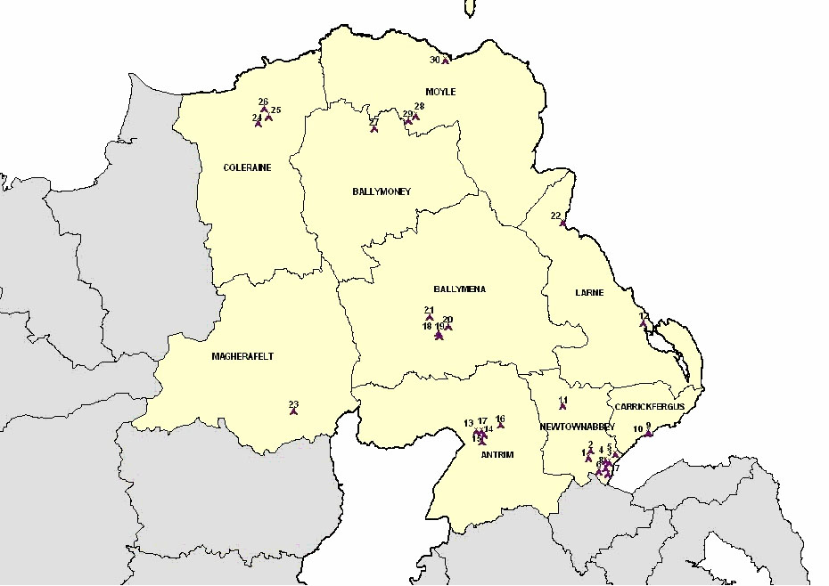



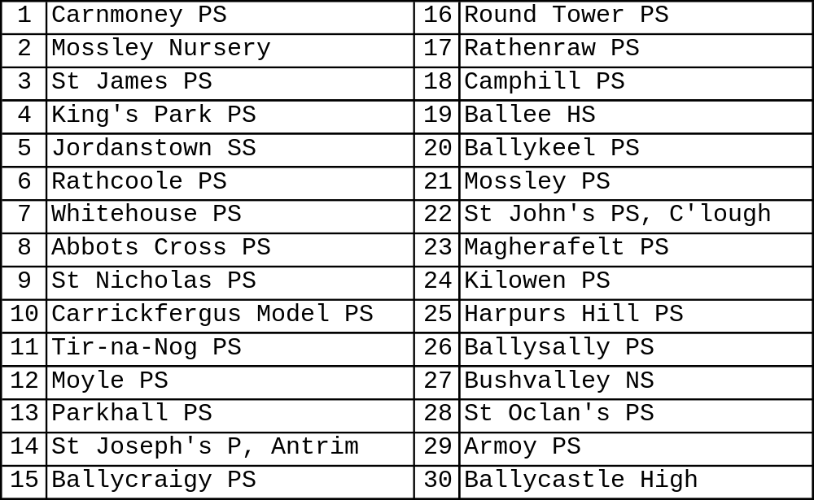
Key to Breakfast Club Schools

NEELB – Schools where Drama/Dance is provided

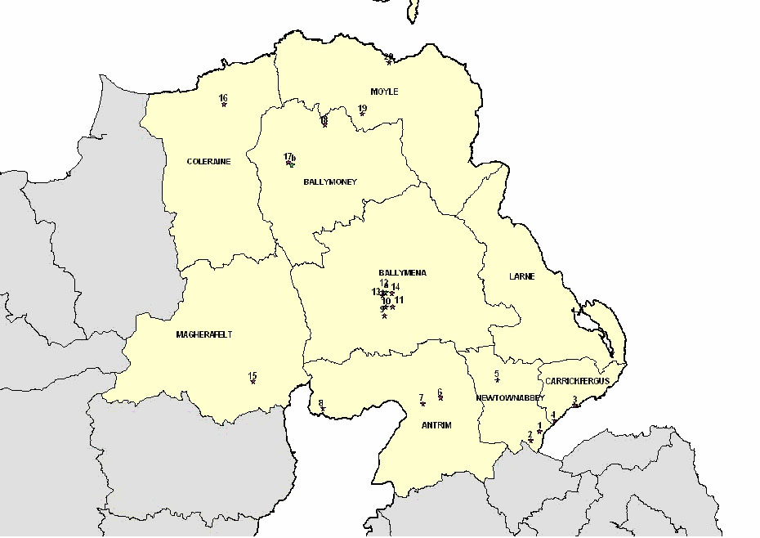

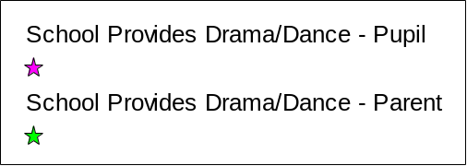

Key to Drama/Dance Schools

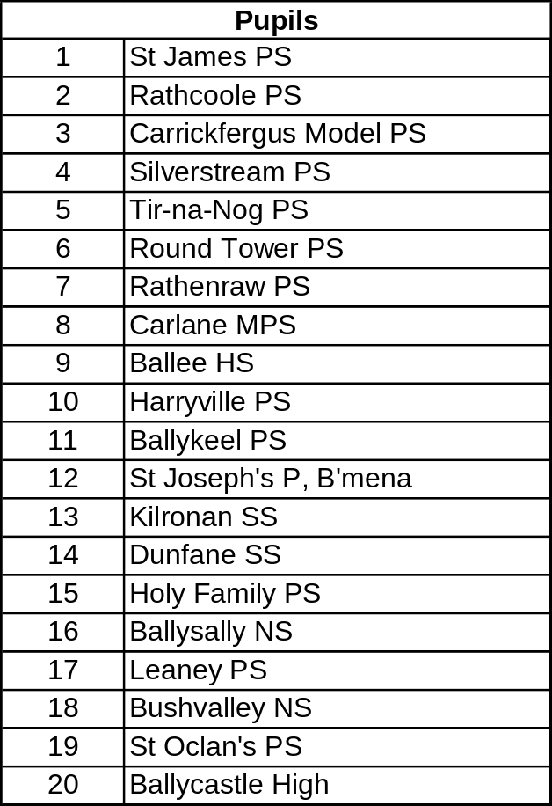


NEELB – Schools where Sporting Programme is provided
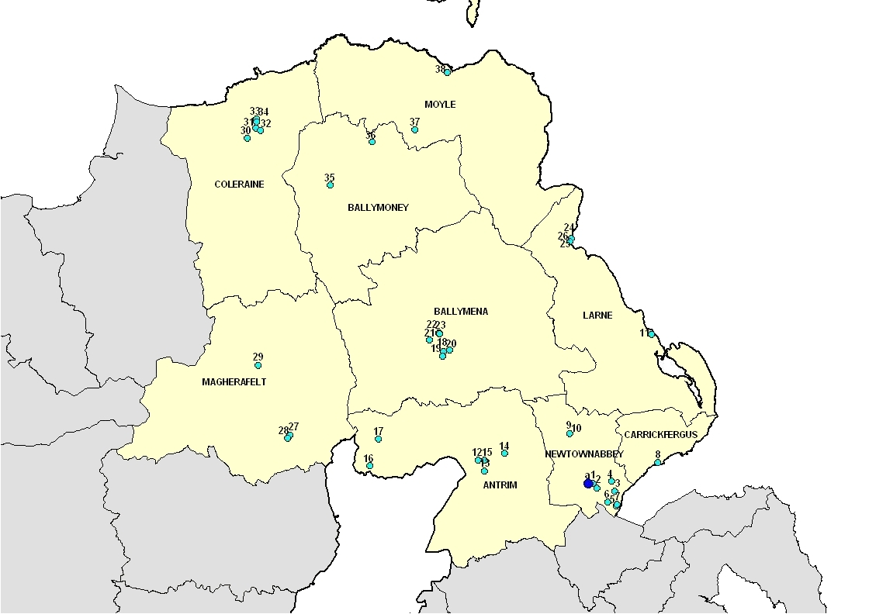

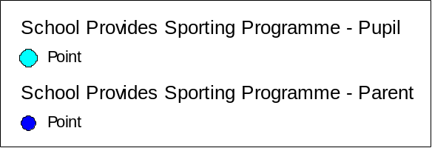

Key to Sporting Programme Schools

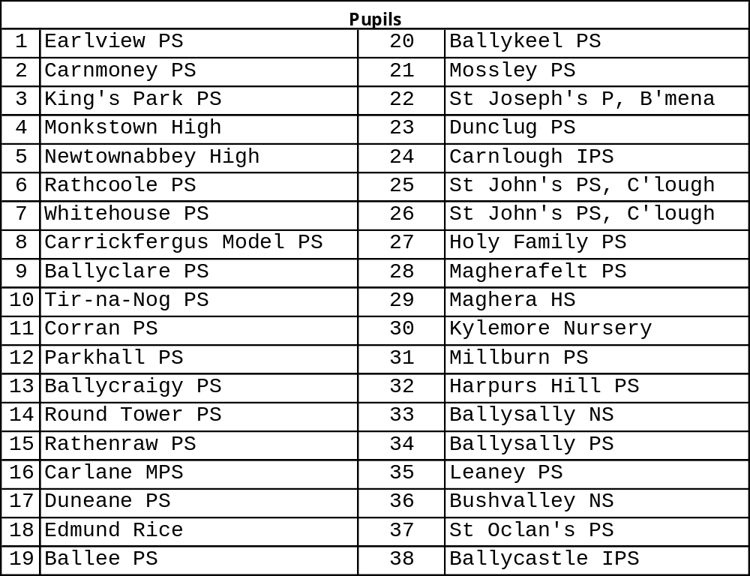


NEELB – Schools where Health & Fitness is provided
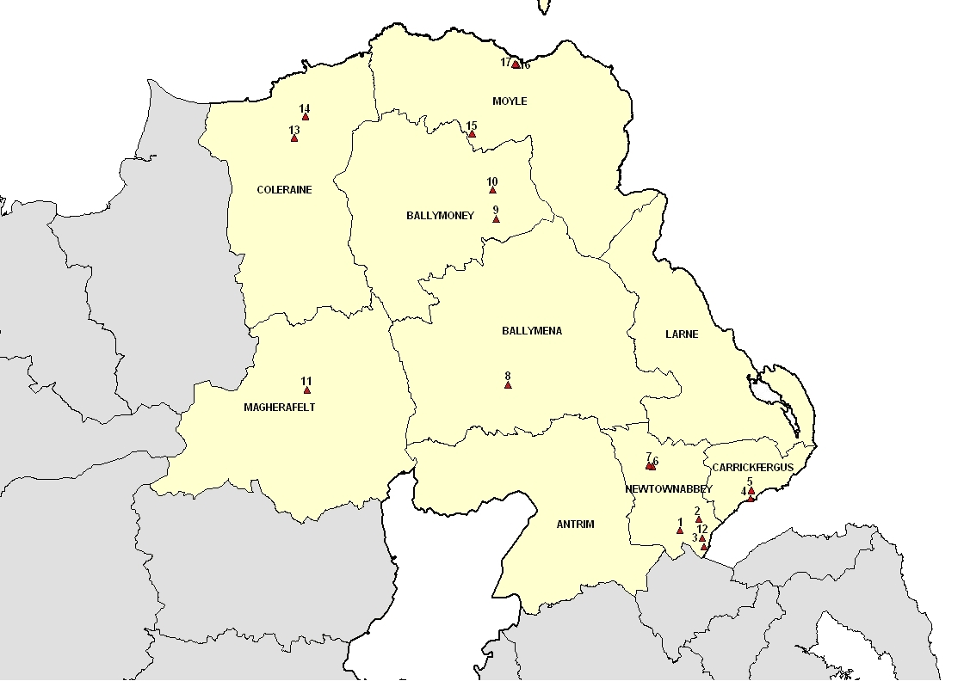

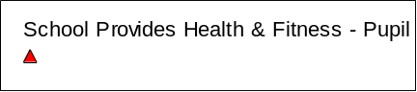

Key to Health & Fitness Schools

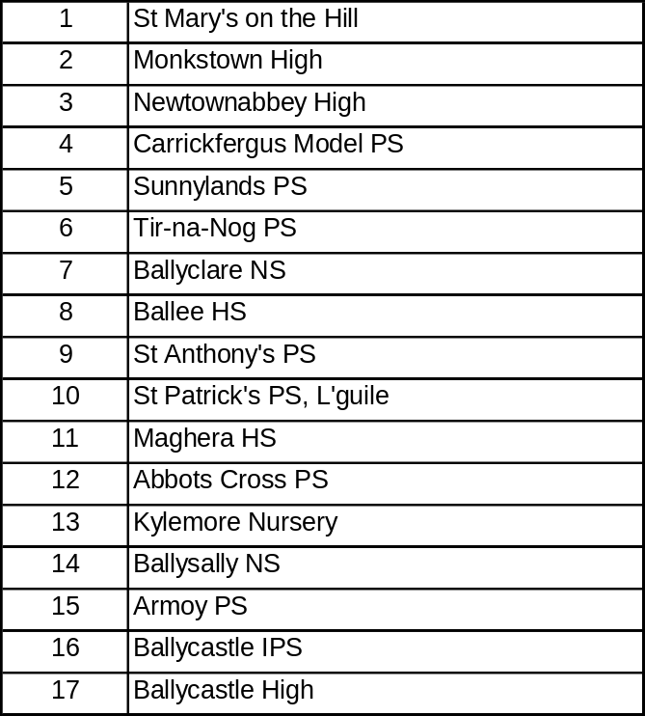

15.0 Acknowledgments

Northern Health and Social Services Board (NHSSB)

Council for Catholic Maintained Schools (CCMS)

Department for Social Development (DSD)

Barnardos

North Eastern Education and Library Board (NEELB) Departments:

Finance
Early Years
Education Welfare
Schools Branch

We would also like to extend a special thanks to Moyra Mann, NHSSB Information Services who provided the maps for Extended Schools Activities and Services.

Some of the same participants attending different activities will have been counted twice.

